Project Report on **Smart Highway Using 8051 Microcontroller**



Central University of Haryana, Mahendergarh

Submitted By

Atul Pandey ( 180915) Ravikant Prasad (180933) Sanjay raj (180937)

Siddharth Sharma (180942)

Submitted in partial fulfillment of the requirements of the degree of

Bachelor of Technology in Electrical Engineering

Submitted to

Dr. Manish Kumar (Assistant Professor) of

**Department of Electrical Engineering School of Engineering & Technology**

**School of Engineering and Technology**

**Central University of Haryana, Mahendergarh**



CERTIFICATE

This is to certify that a project report entitled  **“Smart highway using 8051 microcontroller”**  is submitted by  **Atul Pandey(180915),** Ravikant Prasad(180933), Sanjay raj(180937),Siddharth Sharma (180942) Student of Fourth Year (VII semester ) in Electrical Engineering department of School of Engineering & Technology, Central University of Haryana, Mahendergarh during the academic year 2021-2022. The report has been found satisfactory and is approved for submission.

**(Project Guide) HOD, EE**

# ACKNOWLEDGEMENT

The satisfaction and euphoria that accompany the successful completion of any task would be incomplete without the mentioning of the people whose constant guidance and encouragement made it possible. We take pleasure in presenting before you our project, which is the result of a studied blend of both research and knowledge.

We express our earnest gratitude to our internal guide  **Dr. Manish Kumar Sir,**  Assistant Professor, Department of Electrical Engineering, Central University of Haryana for his constant support, encouragement and guidance. We are grateful for his cooperation and his valuable suggestions.

Finally, we express our gratitude to all other members who are involved either directly or indirectly for the completion of this project.

Atul Pandey (180915)

Ravikant Prasad (180933) Sanjay raj (180937)

Siddharth Sharma (180942)

1

**List of figures**

**Fig number description page no**

1 Windmill Design 13

2 Block Diagram 08

3 Solar cells 15

4 AT89S52 microcontroller 16

5 Pin diagram 20

6 Block diagram representation of 21

embedded system programming

7 Seven segment display 22

8 Interfacing seven segment display 23

to 8051

9 IR obstacle sensor 24

2

**Software, Hardware and programming language**

**Software Specifications**

* Keil µVision IDE
* MC Programming Language: Embedded C
* Proteus PCB Design Suit

**Programmer**: [USBASP](https://www.robotshop.com/letsmakerobots/how-install-usbasp-drivers-windows-8)

**Hardware Specifications**

* 8051 series Microcontroller
* Voltage Regulator
* Diodes
* LED
* Transistor
* Lamp
* Push Button
* IR LED’s
* IR Receivers
* 7- Segment Displays
* Motor
* Register
* Capacitor
* Crystal

3

**Lecture review**

The project aims at saving energy by detecting the vehicle movement on highways and switching on the block of street light ahead of it and simultaneously switching off the trailing lights. The project requires sensors to detect the vehicle movements and switches on the lights ahead of it. As soon as the vehicle moves ahead the trailing lights automatically switches off. This can be used to save a lot of energy instead of using conventional system where the street lights are remained ON.

This proposed system provides a solution for energy saving. This is achieved by sensing an approaching vehicle and then switches ON a block of street lights ahead of the vehicle. As the vehicle passes by, the trailing lights switch OFF automatically. Thus, we save a lot of energy. So when there are no vehicles on the highway, t

Sensors used on either side of the road senses vehicle movement and sends logic commands to microcontroller to switch ON/OFF the LEDs. Thus this way of dynamically changing intensity ON/OFF helps in saving a lot of energy. The sensors sense the vehicle movements and send it to a 8051 family microcontroller that initiates commands for switching the lights ON/OFF.

4

**Table of content**

**Chapter 1 Introduction**

**1.1 Introduction  
1.2 Methodology of working**

**Chapter 2 Wind Energy**

**2.1 Wind Energy  
2.2 Windmill design**

**Chapter3 large turbine**

**3.1 Large turbine**

**3.2 wind turbine: Number of blades**

**3.3 wind power generation**

**Chapter 4 Wind turbine generator**

**4.1 Small generator**

**4.2 large generator**

**4.3 other design consideration**

**Chapter 5 speed breaker power generation**

**5.1 rack and pinion mechanism  
5.2 conclusion**

**5.3 future scope**

**Chapter 6 Block diagram**

**6.1 Hardware specification**

**Chapter 7 solar cell**

**7.1 introduction**

**7.2 How solar cell makes electricity**

**Chapter 8 AT9S52 microcontroller**

**8.1 introduction**

**8.2 Pin configuration** 5

**8.3 programming to AT9S52**

**Chapter 9 Interfacing seven segment display to 8051**

**Chapter 10 IR sensor**

**10.1 IR sensor interfacing with 8051**

**10.2 Specification**

**10.3 working principle of IR obstacle sensor**

**Conclusion**

**Appendix  
References**

6

**Chapter 1 Introduction**

**1.1 Introduction**

During last few decades, electrical energy is the basic requirement of human beings. The ratio of electricity requirement is increasing day by day. But we know that the resources for power generation are limited, and this has caused the energy crisis. The increasing power demand results reduce in conventional resources for power generation and increase the pollutants emissions. It is a need of time to think about non-conventional energy resources or renewable energy resources which are eco-friendly to the environment. In order to minimise the emission of greenhouse gases, renewable energy technologies are widely used for electricity generation. Solar and wind technologies are frequently used for electricity generation. The flow of traffic on rushed load is control by the use of Speed Breakers. The annual rate of motor vehicle growth in India is increasing day by day. The weight of vehicles in term of potential energy can be utilized for electricity generation purposes. To obtain maximum power, the flow of moving vehicles is very important. In this mechanism, a rack and pinions are used. This mechanism converts the kinetic energy of moving vehicles into electric energy with the help of speed breaker on the roads. This is generating many kilowatts of power by using downward as well as the upward motion of rack. Downward motion is caused by load and upward motion is due to restoring force utilizing store power in springs.

**1.2 Methodology of working**

When a car reaches on speed breaker, rack moves downward to generate linear motion . Two pinions are attached to a rack which converts the linear motion of rack into rotary motion. Both pinions have unidirectional motion, like as bicycle sprocket. Two gears are mounted on pinion shaft’s to transfer mechanical power to the common shaft having one gear. At final shaft, a flywheel is used to provide uniform motion. A belt is used to transfer mechanical motion of the common shaft to DC generator. The complete gear box is dipped in lubrication oil sump to minimize frictional losses. There are no chances of slipping between rack and pinions due to guide slots. DC generator generates DC power which is stored in batteries same as in solar technology . The generated power can be used for the domestic purpose or commercially, which are present near the speed breaker.

7

**Chapter 2 Wind Energy**

**2.1 Wind Energy**

Wind energy is the converting of wind power to electrical power through the use of windmills or turbines. electricity produced is sent to transformers where voltage is increased and sent to the power grid via transmission lines.

WIND ENERGY – WHERE IT COMES FROM?

• All renewable energy (except tidal and geothermal power), ultimately comes from the sun.

• The earth receives 1.74 x 1017 watts of power (per hour) from the sun.

• About one or 2 percent of this energy is converted to wind energy (which is about 50-100 times more than the energy converted to biomass by all plants on earth.

• Differential heating of the earth’s surface and atmosphere induces vertical and horizontal air currents that are affected by the earth’s rotation and contours of the land → WIND. ~ e.g.: Land Sea Breeze Cycle.

**2.2 WINDMILL DESIGN**

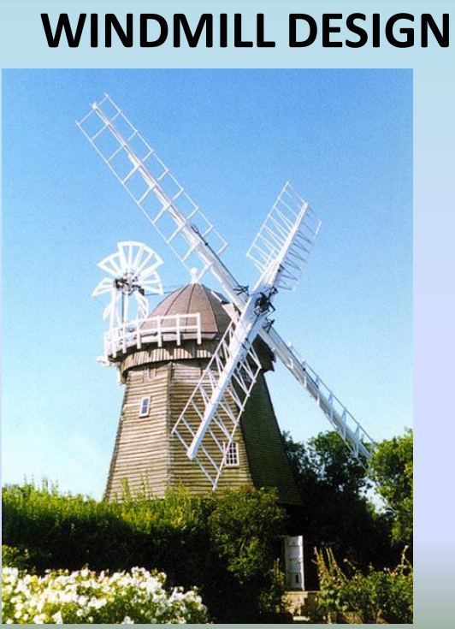

Fig 2

8

• A Windmill captures wind energy and then uses a generator to convert it to electrical energy. • The design of a windmill is an integral part of how efficient it will be.

• When designing a windmill, one must decide on the size of the turbine, and the size of the generator.

**Chapter 3 Large Turbines**

**3.1 LARGE TURBINES**:

• Able to deliver electricity at lower cost than smaller turbines, because foundation costs, planning costs, etc. are independent of size.

• Well-suited for offshore wind plants.

• In areas where it is difficult to find sites, one large turbine on a tall tower uses the wind extremely efficiently.

▪ Local electrical grids may not be able to handle the large electrical output from a large turbine, so smaller turbines may be more suitable.

▪ High costs for foundations for large turbines may not be economical in some areas.

**3.2 Wind Turbines: Number of Blades**

❑ Most common design is the three-bladed turbine. The most important reason is the stability of the turbine. A rotor with an odd number of rotor blades (and at least three blades) can be considered.

❑ A rotor with an even number of blades will give stability problems for a machine with a stiff structure. The reason is that at the very moment when the uppermost blade bends backwards, because it gets the maximum power from the wind, the lowermost blade passes into the wind shade in front of the tower.

• A Windmill captures wind energy and then uses a generator to convert it to electrical energy.

9

• The design of a windmill is an integral part of how efficient it will be.

• When designing a windmill, one must decide on the size of the turbine, and the size of the generator.

**3.3 Wind power generation**

• Wind power generators convert wind energy (mechanical energy) to electrical energy.

• The generator is attached at one end to the wind turbine, which provides the mechanical energy.

• At the other end, the generator is connected to the electrical grid.

• The generator needs to have a cooling system to make sure there is no overheating.

**Chapter 4** **WIND TURBINE GENERATORS**

**4.1 SMALL GENERATORS:**

▪ Require less force to turn than a larger one, but give much lower power output.

▪ Less efficient i.e... If you fit a large wind turbine rotor with a small generator it will be producing electricity during many hours of the year, but it will capture only a small part of the energy content of the wind at high wind speeds.

**4.2** **LARGE GENERATORS:**

▪ Very efficient at high wind speeds, but unable to turn at low wind speeds. i.e.. If the generator has larger coils, and/or a stronger internal magnet, it will require more force (mechanical) to start in motion.

• Winds are influenced by the ground surface at altitudes up to 100 meters.

• Wind is slowed by the surface roughness and obstacles.

• When dealing with wind energy, we are concerned with surface winds.

• A wind turbine obtains its power input by converting the force of the wind into a torque (turning force) acting on the rotor blades.

10

• The amount of energy which the wind transfers to the rotor depends on the density of the air, the rotor area, and the wind speed.

• The kinetic energy of a moving body is proportional to its mass (or weight). The kinetic energy in the wind thus depends on the density of the air, i.e. its mass per unit of volume. In other words, the "heavier" the air, the more energy is received by the turbine.

•At 15° Celsius air weighs about 1.225 kg per cubic meter, but the density decreases slightly with increasing humidity.

**4.3** **OTHER DESIGN CONSIDERATIONS**

A typical 600 kW wind turbine has a rotor diameter of 43-44 meters, i.e. a rotor area of some 1,500 square meters.

➢ The rotor area determines how much energy a wind turbine is able to harvest from the wind.

➢ To be considered a good location for wind energy, an area needs to have average annual wind speeds of at least 12 miles per hour.

A windmill built so that it too severely interrupts the airflow through its cross section will reduce the effective wind velocity at its location and divert much of the airflow around itself, thus not extracting the maximum power from the wind. o At the other extreme, a windmill that intercepts a small fraction of the wind passing through its cross section will reduce the wind’s velocity by only a small amount, thus extracting only a small fraction of the power from the wind traversing the windmill disk. Modern Windmills can attain an efficiency of about 60 % of the theoretical maximum.

**Chapter 5** **Speed Breaker Power Generation**

Electricity is generated by replacing the usual speed breakers with some simple mechanism. As vehicles pass over the speed breakers, rack and pinion mechanism works and with the help of high tension springs in turn generate electricity. This method is an effective way to produce electricity as the number of vehicles is ever increasing. It can be effectively placed near toll plazas, parking lots and other locations where density of vehicles is very high. A rack and pinion, spring assembly mechanism is provided which transfer the motion to a DC motor/generator for electricity generation. 11

This method provides a cost-effective way to generate electricity from the mechanical energy of dynamic vehicles on roads.

**5.1 RACK AND PINION MECHANISM**

Electricity is a basic part of nature and it is one of our most widely used forms of energy. A large amount of energy is wasted at the speed breakers through the dissipation of heat and also through friction, every time a vehicle passes over it. In this research, a roller is fitted in between a speed breaker and some kind of a grip is provided on the speed breaker so that when a vehicle passes over speed breaker it gets displaced in vertically downward direction distance 7 cm. The rack which is connected to the speed breaker also moves down simultaneously with same distance 7 cm. The rack is in mesh with the pinion which is coupled with the shaft of gear which have 72 teeth which then meshed with pinion with 32 teeth which is coupled with the generator motor. This whole mechanism converts linear displacement in rotary motion. Hence shaft of generator rotates which generates current proportional to the number of revolutions of pinion. This produced current is stored in battery for future use. Later the rack gets displaced to the original position due to spring mechanism.

**5.2 CONCLUSION**

In the coming days, demand for electricity will be very high as it is increasing every day, speed breaker power generator will prove a great boom to the world in the Future. The Aim of this project is to introduce another innovative method of green power generation in order to contribute toward developing the world by enriching it with utilization of available resources in more useful manner. Any country, especially Nigeria and other developing nations, can only develop when there is steady and available power supply for its citizens and not by getting breakdown in middle course of time or unreliable power sources. Now time has come for using these types of Innovative ideas and it should be brought into practice. It is suggested that further developments should be done to minimize above mentioned challenges.

**5.3 FUTURE SCOPE**

1) Heavy vehicles can generate high torque using larger pinion and powerful generator and hence the power generated from them will be quite high.

2) More suitable and compact mechanisms to enhance efficiency could be created.

12

3) As these systems are installed on open roads, water accumulates in heavy rainfall regions which may be a threat for working of this system. So, waterproof system can be developed to use this system in heavy rainfall regions also.

4) Multiple generators could be connected so that power generated would be more.

**Chapter 6 Block Diagram**

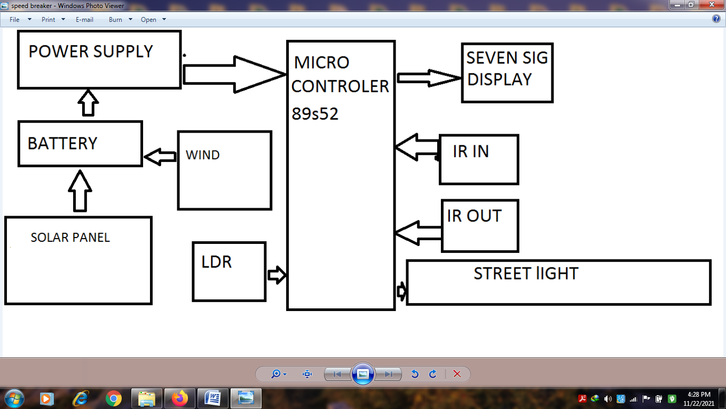

Fig 1

**6.1 Hardware Specifications**

* 8051 series Microcontroller
* Voltage Regulator
* Diodes
* LED
* Transistor
* Lamp
* Push Button
* IR LED’s
* IR Receivers
* 7- Segment Displays
* Motor
* Register 13
* Capacitor
* Crystal

**Chapter 7** **Solar cells: -**

**7.1 Introduction**

Energy comes in different forms. Light is a form of energy. So is heat. So is electricity. Another way to make electricity uses sunlight. Sunshine is free and never gets used up. Also, there is a lot of it. The sunlight that hits the Earth in an hour has more energy than the people of the world use in a year. A little device called a solar cell can make electricity right from sunlight (“solar” means having to do with the Sun). A solar cell doesn’t give off any gases. It doesn’t even make any noise. A solar panel is a group of solar cells that work together. The use of solar cells is growing fast in the United States and many other countries.

**7.2 How Solar Cells Make Electricity**

The cells are made of a type of material known as a semiconductor. Often, they are made of silicon. Semiconductors can conduct, or carry, electricity. They don’t do this as well as metals, however. That is why they are called “semi.” Because they only “semi” conduct electricity, they can be used to control electric current. On their top and bottom they typically have metal contacts through which current can flow. A typical simple cell has two layers of silicon. One is known as n-type. The other is p-type. The layers are different from each other. The process of making electricity begins when the silicon atoms absorb some light. The light’s energy knocks some electrons out of the atoms. The electrons flow between the two layers. The flow makes an electric current .The current can leave the cell through the metal contacts and be used. When light hits a solar cell, much of its energy is wasted. Some light bounces off or passes through the cell. Some is turned into heat. Only light with the right wavelengths, or colors, is absorbed and then turned into electricity.

14

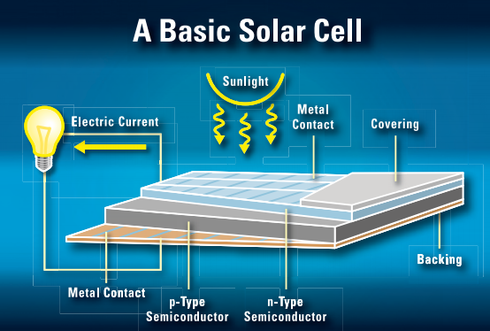

Fig 3

A single simple solar cell makes only a little electricity. For most purposes more is needed. For this reason, cells are often linked together in groups known as solar modules. A solar module has a frame that holds the cells. Some modules are several feet long and wide. They usually can produce up to a few hundred watts of electricity. If more power is needed, modules can be joined together to form a large solar array.

**The Price of Solar Panels: -**

While sunshine is free, solar panels are not. Getting a solar system for a building costs money. In many cases today, the total cost may turn out to be so high that it’s cheaper to get power from the grid. This may change in the future, though, as the cost of electricity made by power plants using oil goes up. Also, as more solar panels are used, the price of the panels may come down. Solar power plants that are able to make large amounts of electricity need large amounts of land—and also lots of solar panels that are costly today. Most electricity used in the United States comes from the public power grid. Sometimes the demand for power is almost more than the grid can handle. People can help out by making some of their own electricity. This eases the load on the grid. But that’s not all it can do. Using a renewable “fuel” like sunlight to make electricity saves on nonrenewable fuels, such as oil or coal. It also avoids the pollution that comes from burning oil or coal.

15

Of course, another good way to reduce use of nonrenewable fuels is to just use less electricity. People can cut down. how much electricity they use simply by doing things like switching off the lights when they leave a room.

**Chapter 8 AT89S52 microcontroller**

**8.1 Introduction**

The **AT89S52**comes from the popular 8051 family of Atmel Microcontrollers. It is an 8-bit CMOS microcontroller with 8K as Flash memory and 256 bytes of RAM. Since it is similar to the trust worthy 8051 architecture these microcontrollers are as per industry standard. It has 32 I/O pins comprising of three 16-bit timers, external interrupts, full-duplex serial port, on-chip oscillator and clock circuitry.

The Microcontroller also has Operating mode, Idle Mode and Power down mode which makes it suitable for battery operated applications.

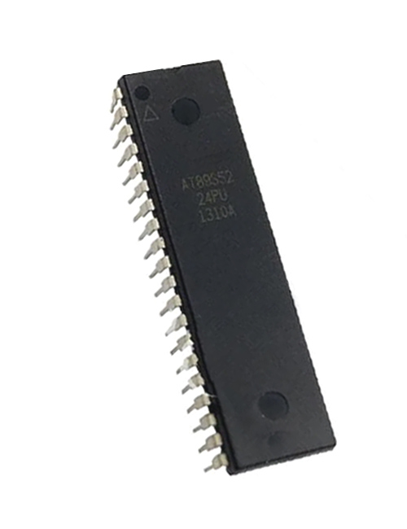**Fig 4**

8.2 AT89S52 Pin Configuration

|  |  |  |
| --- | --- | --- |
| **Pin Number** | **Pin Name** | **Description** |
| 1 | P1.0 (T2) | Timer/Counter or 0th GPIO pin of PORT 1 |
| 2 | P1.1 (T2.EX) | Timer/Counter/External Counter or 1st GPIO pin of PORT 1 |
| 3 | P1.2 | 2nd GPIO pin of PORT 1 |
| 4 | P1.3 | 3rd GPIO pin of PORT 1 |
| 5 | P1.4 | 4th GPIO pin of PORT 1 |
| 6 | P1.5 (MOSI) | MOSI for in System Programming or 5th GPIO pin of PORT 1 |
| 7 | P1.6 (MISO) | MISO for in System Programming or 6th GPIO pin of PORT 1 |
| 8 | P1.7 (SCK) | SCK for in System Programming or 7th GPIO pin of PORT 1 |
| 9 | RST | Making this pin high will reset the Microcontroller |
| 10 | P3.0 (RXD) | RXD Serial Input or 0th GPIO pin of PORT 3 |
| 11 | P3.1 (TXD) | TXD Serial Output or 1st GPIO pin of PORT 3 |
| 12 | P3.2 (INT0’) | External Interrupt 0 or 2nd GPIO pin of PORT 3 |
| 13 | P3.3 (INT1’) | External Interrupt 1 or 3rd GPIO pin of PORT 3 |
| 14 | P3.4 (T0) | Timer 0 or 4th GPIO pin of PORT 3 |
| 15 | P3.5 (T1) | Timer 1 or 5th GPIO pin of PORT 3 |
| 16 | P3.6 (WR’) | Memory Write or 6th GPIO pin of PORT 3 |
| 17 | P3.7 (RD’) | Memory Read or 7th GPIO pin of PORT 3 |
| 18 | XTAL2 | External Oscillator Output |
| 19 | XTAL1 | External Oscillator Input |
| 20 | GND | Ground pin of MCU |
| 21 | P2.0(A8) | 0th GPIO pin of PORT 2 |
| 22 | P2.1 (A9) | 1st GPIO pin of PORT 2 |
| 23 | P2.2 (A10) | 2nd GPIO pin of PORT 2 |
| 24 | P2.3 (A11) | 3rd GPIO pin of PORT 2 |
| 25 | P2.4 (A12) | 4th GPIO pin of PORT 2 |
| 26 | P2.5 (A13) | 5th GPIO pin of PORT 2 |
| 27 | P2.6 (A14) | 6th GPIO pin of PORT 2 |
| 28 | P2.7 (A15) | 7th GPIO pin of PORT 2 |
| 29 | PSEN’ | Program store Enable used to read external program memory |
| 30 | ALE / PROG’ | Address Latch Enable / Program Pulse Input |
| 31 | EA’ / VPP | External Access Enable / Programming enable Voltage |
| 32 | P0.7 (AD7) | Address / Data pin 7 or 7th GPIO pin of PORT 0 |
| 33 | P0.6 (AD6) | Address / Data pin 6 or 6th GPIO pin of PORT 0 |
| 34 | P0.5 (AD5) | Address / Data pin 5 or 5th GPIO pin of PORT 0 |
| 35 | P0.4 (AD4) | Address / Data pin 4 or 4th GPIO pin of PORT 0 |
| 36 | P0.3 (AD3) | Address / Data pin 3 or 3rd GPIO pin of PORT 0 |
| 37 | P0.2 (AD2) | Address / Data pin 2 or 2nd GPIO pin of PORT 0 |
| 38 | P0.1 (AD1) | Address / Data pin 1 or 1st GPIO pin of PORT 0 |
| 39 | P0.0 (AD0) | Address / Data pin 0 or 0th GPIO pin of PORT 0 |
| 40 | VCC | Positive pin of MCU (+5V) |

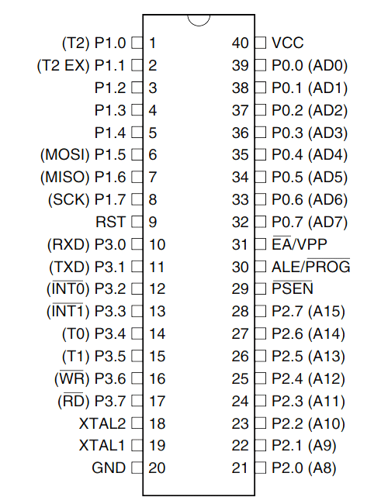**Fig 5**

8.3Programming AT89S52 Microcontroller

Atmel microcontroller can be programmed with different software's that is available in the market. Arduino, Keil uVision are the most used platforms to name a few.

In order to program the Atmel microcontroller we will need an IDE (Integrated Development Environment), where the programming takes place. A compiler, where our program gets converted into MCU readable form called HEX files. An IPE (Integrated Programming Environment), which is used to dump our hex file into our MCUs.

IDE: [Keil uVision IDE](https://www.keil.com/download/)

Programming Hardware: USB In-circuit programmer (USBASP)

Programmer: [USBASP](https://www.robotshop.com/letsmakerobots/how-install-usbasp-drivers-windows-8) 20

To dump or upload our code into Atmel IC we need a programmer, the most commonly used programmer is the USBASP which has to be purchased separately.

**Embedded C is most popular programming** **language** in software field for developing electronic gadgets. Each processor used in electronic system is associated with embeddedsoftware. Embedded C programming plays a key role in performing specific function by the processor. In day-to-day life we used many electronic devices such as mobile phone, washing machine, digital camera, etc. These all-device working is based on microcontroller that are programmed by embedded C.

Let's see the **block diagram representation of embedded system programming**:

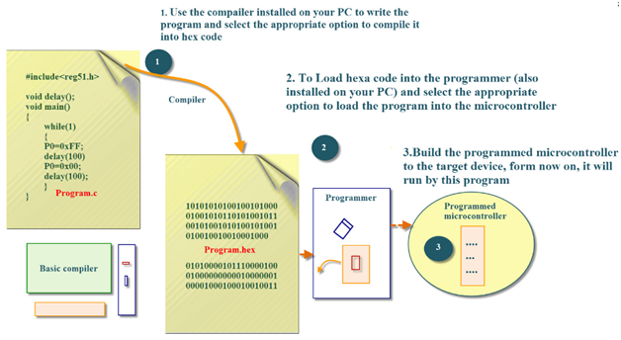 **Fig 6**

In embedded system programming C code is preferred over other language. Due to the following reasons:

* Easy to understand
* High Reliability
* Portability
* Scalability

21

**8.3 Software Specifications**

* Keil µVision IDE
* MC Programming Language: Embedded C

**Chapter 9 Interfacing seven segment display to 8051**

### Fig 7

Interface a seven segment LED display to an 8051 microcontroller. 7 segment LED display is  very popular and it can display digits from 0 to 9 and quite a few characters like A, b, C, ., H, E, e, F, n, o,t,u,y, etc.

The circuit diagram shown below is of an AT89S51 microcontroller based 0 to 9 counter which has a 7 segment LED display interfaced to it in order to display the count.  This simple circuit illustrates two things. How to setup simple 0 to 9 up counter using 8051 and more importantly how to interface a seven segment LED display to  8051 in order to display a particular result. The common cathode seven segment display D1 is connected to the Port 1 of the microcontroller (AT89S51) as shown in the circuit diagram. R3 to R10 are current limiting resistors. S3 is the reset switch and R2,C3 forms a debouncing circuitry. C1, C2 and X1 are related to the clock circuit. The software part of the project has to do the following tasks.

* Form a 0 to 9 counter with a predetermined delay (around 1/2 second here).
* Convert the current count into digit drive pattern.
* Put the current digit drive pattern into a port for displaying.

22

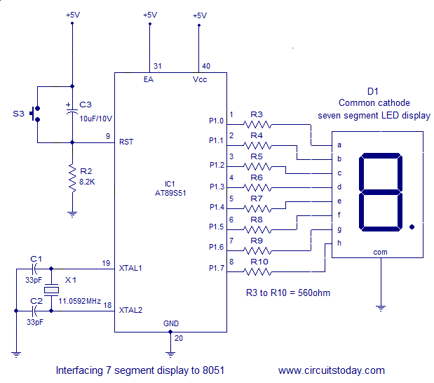Fig 8

**Chapter 10 IR Sensor**

**10.1 IR Sensor Interfacing With 8051**

Infrared is light that has a wavelength longer than visible red light. The ranges of infrared include near-infrared, mid-infrared, and far-infrared, spanning wavelengths from about 710 nanometers (near-infrared) to 100 micrometers (far infrared).

All objects emit light according to their temperature–this is called “black body radiation.” The hotter the object, the shorter wavelength of light it emits.

**The infrared Obstacle Sensor Module** has a built-in **IR transmitter** and **IR receiver** that sends out IR energy and looks for reflected IR energy to detect the presence of any obstacle in front of the sensor module. The PCB of this electronic circuit has a potentiometer. That onboard potentiometer lets users adjust the detection range. The sensor has a very good and stable response even in ambient light or in complete darkness.

**10.2 Specifications**

1.Operating Voltage:**3.0V – 5.0V**

2.Detection range:**2cm – 30cm (Adjustable using potentiometer)**

23

3.Current Consumption: **at 3.3V : ~23 mA** ,**at 5.0V: ~43 mA**

4.Active output level: **Outputs Low logic level when an obstacle is detected**

5.Onboard Obstacle Detection LED indicator

**10.3 Working Principle of IR Obstacle Sensor**

An IR sensor consists of an IR LED and an IR Photodiode; together they are called as Photo–Coupler or Opto–Coupler. As said before, the Infrared Obstacle Sensor has a built-in IR transmitter and IR receiver. An **infrared Transmitter** is a light-emitting diode (LED) that emits infrared radiations. Hence, they are called IR LED. Even though an IR LED looks like a normal LED, the radiation emitted by it is invisible to the human eye.

Working Principle of IR Obstacle Sensor

An IR sensor consists of an IR LED and an IR Photodiode; together they are called as Photo–Coupler or Opto–Coupler. As said before, the Infrared Obstacle Sensor has a built-in IR transmitter and IR receiver. An **infrared Transmitter** is a light-emitting diode (LED) that emits infrared radiations. Hence, they are called IR LED. Even though an IR LED looks like a normal LED, the radiation emitted by it is invisible to the human eye.

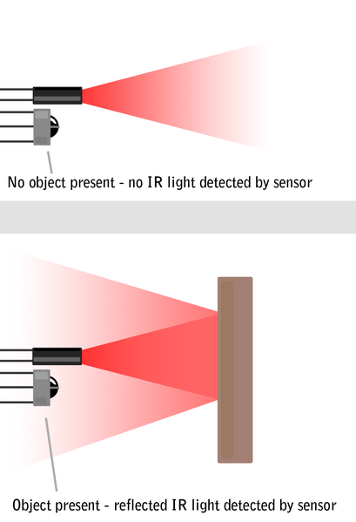

**Fig 9**

24

**Conclusion**

After completing our project we conclude that this will improve energy generation (ecofriendly energy) and this technology will save energy by switching off all the lights at the highway. The future use of this project is the energy that we get from the solar energy and wind energy and we can store this energy at highway to use at DC point for charging the electric vehicle. By using the microcontroller, we can control the street light at the highway and also save that energy

25

**Appendix**

**Code for 8051 microcontroller**

#include<reg51.h>

#define SEGMENT P0

sbit switch1=P3^0;

sbit switch2=P3^1;

sbit digit1=P2^0;

sbit digit2=P2^1;

void delay (int);

int x=0,y,z;

unsigned char ch[]={0xc0,0xf9,0xa4,0xb0,0x99,0x92,0x82,0xf8,0x80,0x98};

void delay (int d)

{

unsigned char i;

for(;d>0;d--)

{

for(i=250;i>0;i--);

for(i=248;i>0;i--);

}

}

void main()

{

switch1=1;

switch2=1;

digit1=1;

digit2=1;

while(1)

{

if(switch1==0)

{

x++;

delay(200);

}

else if(switch2==0)

{

x--;

delay(200); 26

}

y=x/10;

SEGMENT=ch[y];

digit1=0;

delay(10);

digit1=1;

z=x%10;

SEGMENT=ch[z];

digit2=0;

delay(10);

digit2=1;

}}

27

**References**

1. <https://www.javatpoint.com/embedded-system-7-segment-display>
2. <https://www.javatpoint.com/embedded-system-8051-microcontroller>
3. <https://www.javatpoint.com/embedded-system-7-segment-display>
4. <https://embetronicx.com/tutorials/microcontrollers/8051/ir-sensor-interfacing-with-8051/>
5. <https://www.elprocus.com/infrared-ir-sensor-circuit-and-working/>
6. <https://www2.keil.com/mdk5/uvision/>
7. <https://www.javatpoint.com/embedded-system-c-programming>
8. <https://en.wikipedia.org/wiki/Embedded_C>
9. <https://www.irena.org/wind#:~:text=Wind%20power%20is%20one%20of%20the%20fastest%2Dgrowing%20renewable%20energy%20technologies.&text=Wind%20is%20used%20to%20produce,or%20wind%20energy%20conversion%20systems>.

10.<https://www.britannica.com/technology/solar-cell>

11. <https://www.electrical4u.com/solar-cell/>

28